[Jim's Baru ]

Star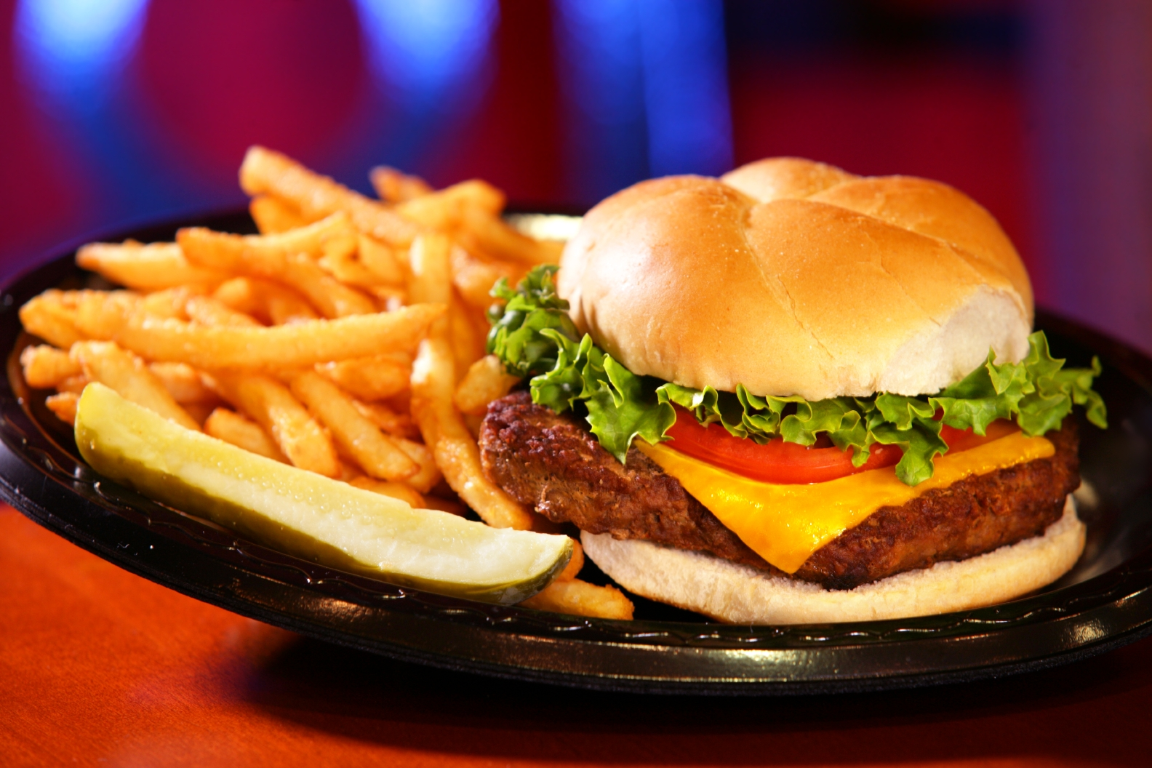ter

[Starter Item]
[Description]

[Starter Item]
[Description]

Main Course

[Main Course Item]
[Description]

[Main Course Item]
[Description]

Dessert

[Dessert Item]
[Description]

[Dessert Item]
[Description]

